Linux Programming
Assignment-4
Nanditha M
ENG24CY0038

Q1) 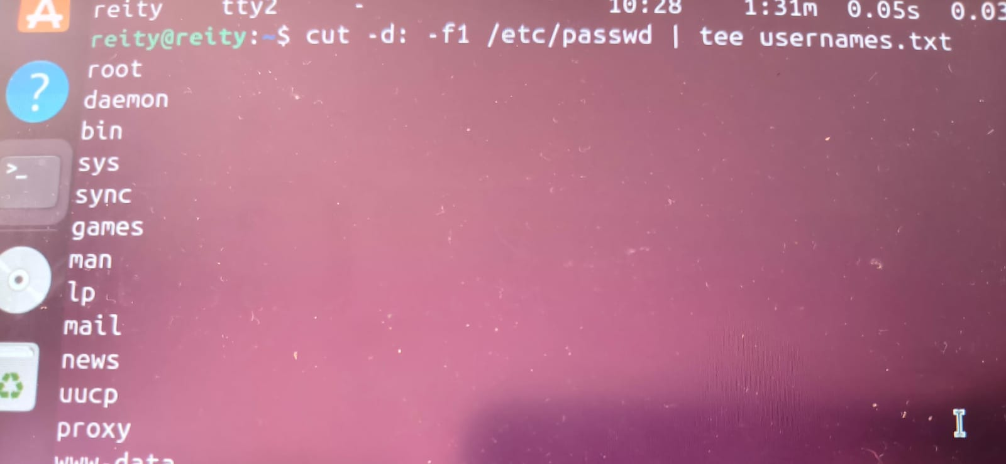

Q2) which binary_name → check if shell can find it.
find / -name binary_name → locate binary manually.
locate binary_name → fast search using database.
Add the directory to $PATH → shell can now find it.

Q3) find /var/log -type f -name "*.log" -mtime -1 | tee log_report.txt ,
This command finds all .log files modified in the last 24 hours in /var/log and saves results into log_report.txt.

Q4) shutdown -r now
- shutdown → safely shuts down the system.
- -r → tells the system to reboot after shutdown.
- now → executes immediately.
reboot
- reboot → immediately restarts the system.
- Often a shortcut for shutdown -r now, but behavior depends on system configuration.
- Some older systems may not safely terminate processes, but on modern Linux (systemd) it usually behaves the same as shutdown -r now.

Q5) ./myscript.sh | tee output.log
Saves standard output to output.log while displaying it on the terminal.
Error messages (stderr) are still displayed on the terminal, but not saved.
Capture both stdout and stderr
./myscript.sh 2>&1 | tee debug.log

Q6) 1. Web Servers & Cloud Infrastructure
- Description: Linux powers most web servers and cloud platforms.
- Why Linux: Stable, secure, cost-effective, supports scripting and automation.
- Examples:
  - Apache, Nginx, and Tomcat web servers run on Linux.
  - Cloud platforms like AWS, Google Cloud, and Azure use Linux extensively.
Industry Use: Tech companies, e-commerce sites, and online services rely on Linux for hosting applications.
2. Embedded Systems & IoT Devices
- Description: Linux runs on smart devices and embedded systems.
- Why Linux: Lightweight (can run on small hardware), customizable, and stable.
- Examples:
  - Automobiles: Infotainment systems, navigation, engine control
  - Smart home devices: Smart TVs, routers, security cameras
  - Medical devices: Patient monitors and imaging equipment
Industry Use: Automotive, healthcare, and consumer electronics rely on Linux for device control and connectivity.
3. Scientific Computing & Supercomputers
- Description: Linux dominates high-performance computing (HPC) and scientific research.
- Why Linux: Open-source, scalable, supports parallel processing, and handles large datasets efficiently.
- Examples:
  - Most of the Top500 supercomputers run Linux.
  - Used in genomics, weather forecasting, physics simulations, AI research.
Industry Use: Research labs, universities, weather agencies, and AI/ML companies use Linux for complex computations.

Q7) 1. Application Software
- Purpose: Designed to perform specific tasks for the user.
- Examples in Linux:
  - LibreOffice → word processing, spreadsheets
  - GIMP → image editing
  - Firefox → web browsing
- Characteristics:
  - Runs on top of the OS
  - Directly interacts with the user
2. System Software
- Purpose: Manages hardware and provides a platform for applications to run.
- Examples in Linux:
  - Linux Kernel → core of the OS, manages CPU, memory, devices
  - Systemd → manages system startup and services
  - X Server → handles graphics display
- Characteristics:
  - Operates between hardware and applications
  - Essential for the system to function
3. Utility Software
- Purpose: Helps in maintaining, optimizing, or analyzing the system.
- Examples in Linux:
  - fsck → check filesystem integrity
  - top → monitor system processes
  - tar, gzip → compress and archive files
  - dd → disk management and backups
- Characteristics:
  - Performs specific maintenance or system tasks
  - Often command-line tools in Linux

Q8) 1. Open-Source Operating Systems
- Source Code: Freely available to view, modify, and distribute.
- Examples: Linux (Ubuntu, Fedora), FreeBSD.
- Cost: Usually free.
- Customization: Highly customizable; users can change OS behavior.
- Support: Community-driven forums and documentation; may lack official support.
- Security: Transparent; vulnerabilities can be quickly fixed by the community.
- Licensing: Uses open-source licenses like GPL.
2. Proprietary Operating Systems
- Source Code: Not available; users cannot see or modify the code.
- Examples: Windows, macOS, iOS.
- Cost: Paid; license required.
- Customization: Limited to what the vendor allows.
- Support: Official vendor support is available.
- Security: Users rely on vendor updates; not transparent.
- Licensing: Closed-source license; copying/modifying is prohibited

Q9) 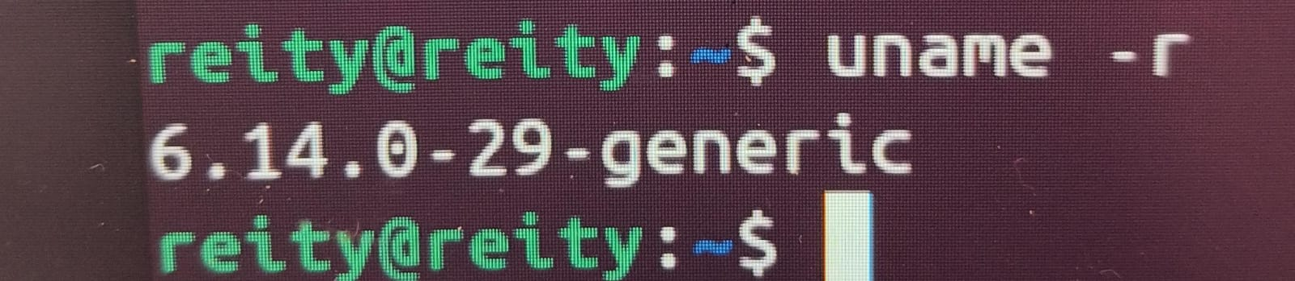

Q10) 1. head Command
- Purpose: Displays the beginning (top) part of a file.
- Default Behavior: Shows the first 10 lines.
- Options:
  - -n <number> → show first <number> lines
  - -c <number> → show first <number> bytes
2. tail Command
- Purpose: Displays the ending (bottom) part of a file.
- Default Behavior: Shows the last 10 lines.
- Options:
  - -n <number> → show last <number> lines
  - -f → follow the file as it grows (useful for logs)

